ECA5701-NANOELECTRONICS C01-4
ATHIRA A J 192512205
EXPERIMENT 4
Kronig Penney Model
Aim: To simulate Energy functional vs Energy graph using Kronig Penney model
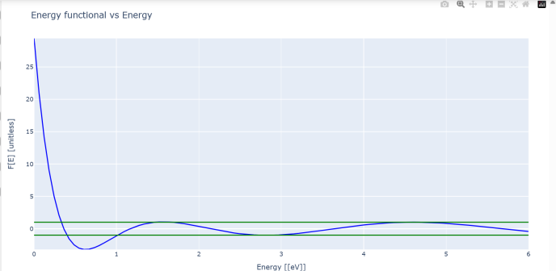
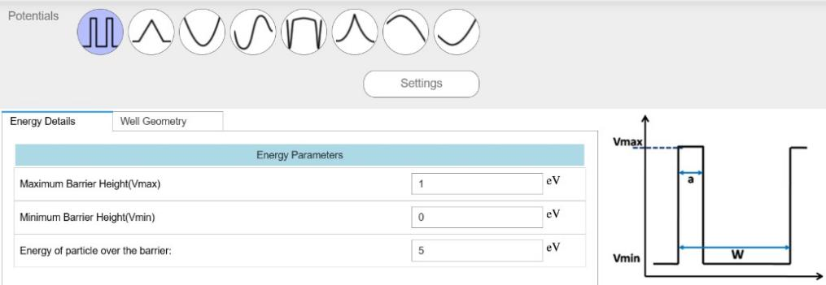

Case Study 1: Simulate the output for Triangular well
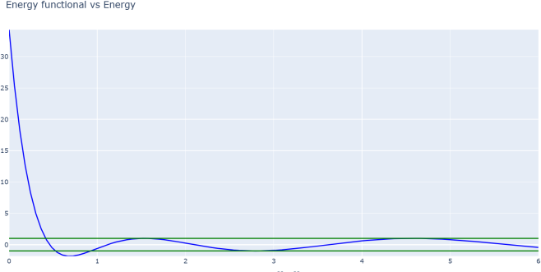

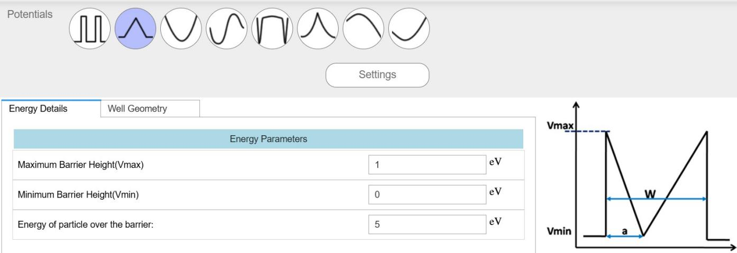

Case Study 2: Simulate the output for Sinusoidal Potential
